Making Human Connections

Based on what you reviewed from career research and the possible lives exercise, what types of connections would you like to make? List career fields where you would like to meet someone, job titles of people you might like to meet, and companies that seem interesting to you below:

Who do you already know who could help you find introductions to the types of people you listed above? Write down real names. They may be faculty, supervisors, coworkers, friends, etc.

Let’s find real people online using LinkedIn’s alumni feature https://www.linkedin.com/school/unc-asheville/people/

Search for alumni who either live in a city you want to move to, have your major, or have a career you find interesting. List the alumni here:

Additional methods to find real people:
- Networking groups in town
- Looking in company directories online for real humans

You have options, once you have identified new connections you want to make, you can reach out to them directly if you have their contact information or can find it on their company’s website, you can try to connect with them on LinkedIn (limited to 200 characters), or you can ask the Career Center for a connection.

Either way, you’ll need to introduce yourself. Practice writing an introduction email. Here is an example:

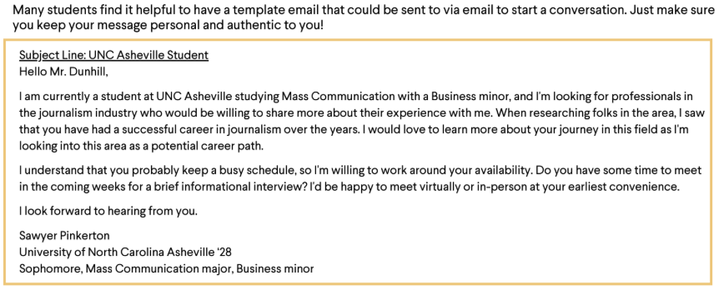

Try writing your own introduction email here: (remember, you’ll have to shorten it, if you reach out via LinkedIn)

